Transmitter_190318/

DOCUMENTATION
stuttgart, march 2023

CONTENTS
1. ADDING NEW MODULES 3
1.1. FILE STRUCTURE 3
1.2. DATA 4
1.2.1. Structure 4
1.2.2. Editing the Data 4
1.3. HTML 17
1.4. IMAGES 17
1.5. VIDEOS 18
1.6. BAT FILE 18

ADDING NEW MODULES

FILE STRUCTURE
EXISTING FOLDERS
NEW FOLDERS
NEW FILES

Folders/files to add:
- Transmitter_190318
  - data
    - TXX
      - de.json
      - en.json
  - html
    - TXX.html
  - images
    - TXX
      - 00_Idle_Start
        - TXX_00_Start_01.webp
      - 01_Geschichte
        - TXX_01_Geschichte_01.webp
        - TXX_01_Geschichte_02_01.webp
        - TXX_01_Geschichte_02_02.webp
        - TXX_01_Geschichte_02_03.webp
        - TXX_01_Geschichte_03.webp
      - 02_Heute
        - TXX_02_Heute_01.webp
        - TXX_02_ Heute _02_01.webp
        - TXX_02_ Heute _02_02.webp
        - TXX_02_ Heute _02_03.webp
        - TXX_02_ Heute _03.webp
      - 03_Service
        - TXX_03_Service_01_01.webp
  - Videos
    - TXX
      - TXX_00_Idle_01.mp4
  - TXX.bat

DATA
Make a new folder inside the Data folder called TXX where XX is the new module number.

Example: if the new module is 25, The folder should be called T25

The simplest way to do this is to make a copy of the T99 folder and rename it to TXX where XX is the number of the new module.

Inside this folder, there should be two .json files:

de.json the German version of the data
en.json the English version of the data

Idle Section
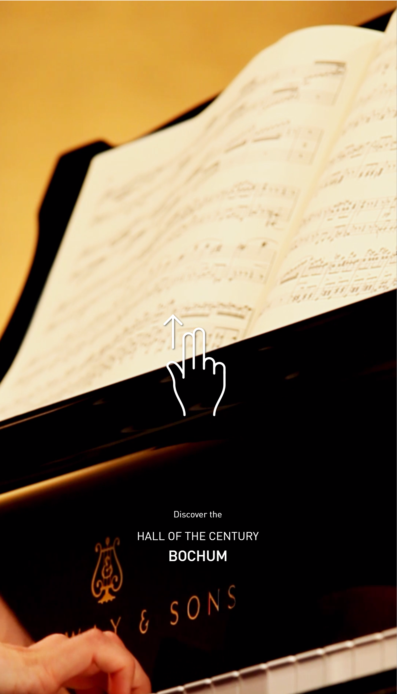
"idle": {
"video": "T01_00_Idle_01.mp4",
"labels": [
{
"pre": "Entdecke die",
"headline": "Jahrhunderthalle",
"subline": "Bochum"
},
{
"pre": "Discover the",
"headline": "Hall of the Century",
"subline": "Bochum"
}
]
},

Here the idle screen is playing the T01_00_Idle_01.mp4 video
It also switches between two sets of text in German and English.

Content Sections

There are several sections in each layout. These sections are:
- Intro
- History
- Today
- Service

Main Content Layouts

Layout m07
The m07 layout consists of multiple pieces of content, each with its own image and description
{
"type": "m07",
"media": [
{
"type": "image",
"src": "02_Heute/T07_02_Heute_01_01.webp",
"description": {
"copy": "Description text goes here"
}
},
{
"type": "image",
"src": "02_Heute/T07_02_Heute_01_02.webp",
"description": {
"copy": "Description text goes here"
}
},
{
"type": "image",
"src": "02_Heute/T07_02_Heute_01_03.webp",
"description": {
"copy": "Description text goes here"

}
}
]
},

Layout m03
The m03 layout is one image with one description.
{
"type": "m03",
"media": [
{
"type": "image",
"src": "02_Heute/T07_02_Heute_02.webp",
"description": {
"copy": "Put the description text here."
}
}
]
},

Layout m06
The m06 layout consists of different swipe-able images with one description.
{
"type": "m06",
"description": {
"copy": "Description Text Goes Here"
},
"media": [
{
"type": "image",
"src": "02_Heute/T07_02_Heute_06_01.webp"
},
{
"type": "image",
"src": "02_Heute/T07_02_Heute_06_02.webp"
},
{
"type": "image",
"src": "02_Heute/T07_02_Heute_06_03.webp"
}
]
},

Intro Section
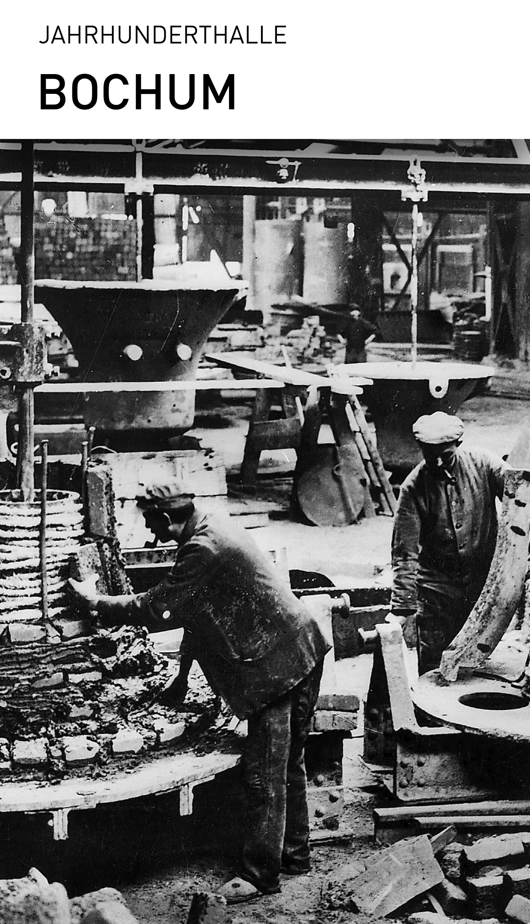
"sections": [
{
"id": "intro",
"class": "category-intro",
"headline": "Jahrhunderthalle",
"subline": "Bochum",
"modules": [
{
"type": "m02",
"media": [
{
"type": "image",
"src": "00_Idle_Start/T07_00_Start_01.webp",
"description": {}
}
]
}
]
},
Inside the Intro Section, there is typically one module.
The template (type) is typically m02

History

Module m03
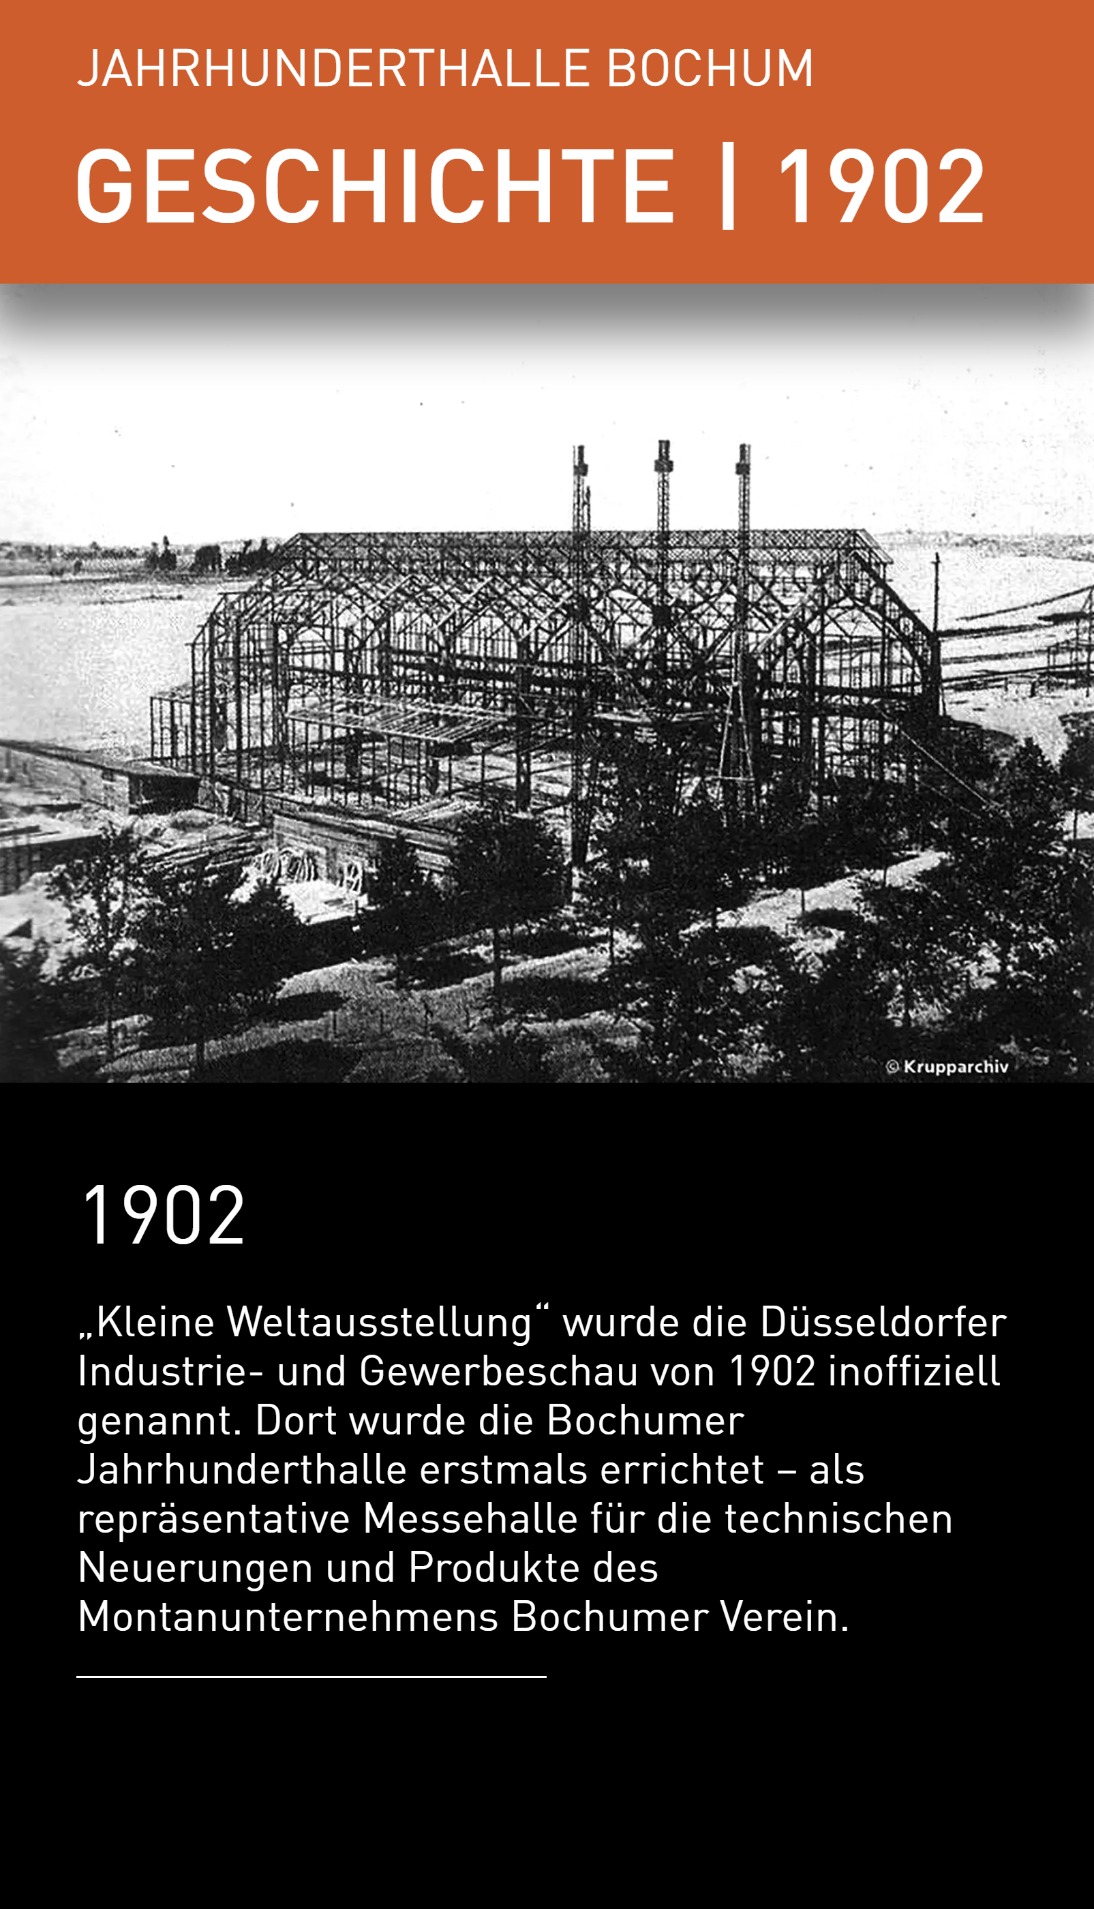
{
"id": "history",
"class": "category-history",
"headline": "Jahrhunderthalle Bochum",
"subline": "GESCHICHTE",
"year": true,
"modules": [
{
"type": "m03",
"year": "1902",
"media": [
{
"type": "image",
"src": "01_Geschichte/T07_01_Geschichte_01.webp",
"description": {
"headline": "1902",
"copy": "„Kleine Weltausstellung“ wurde die Düsseldorfer Industrie- und Gewerbeschau von 1902 inoffiziell genannt. Dort wurde die Bochumer Jahrhunderthalle erstmals errichtet – als repräsentative Messehalle für die technischen Neuerungen und Produkte des Montanunternehmens Bochumer Verein. "
}
}
]
},

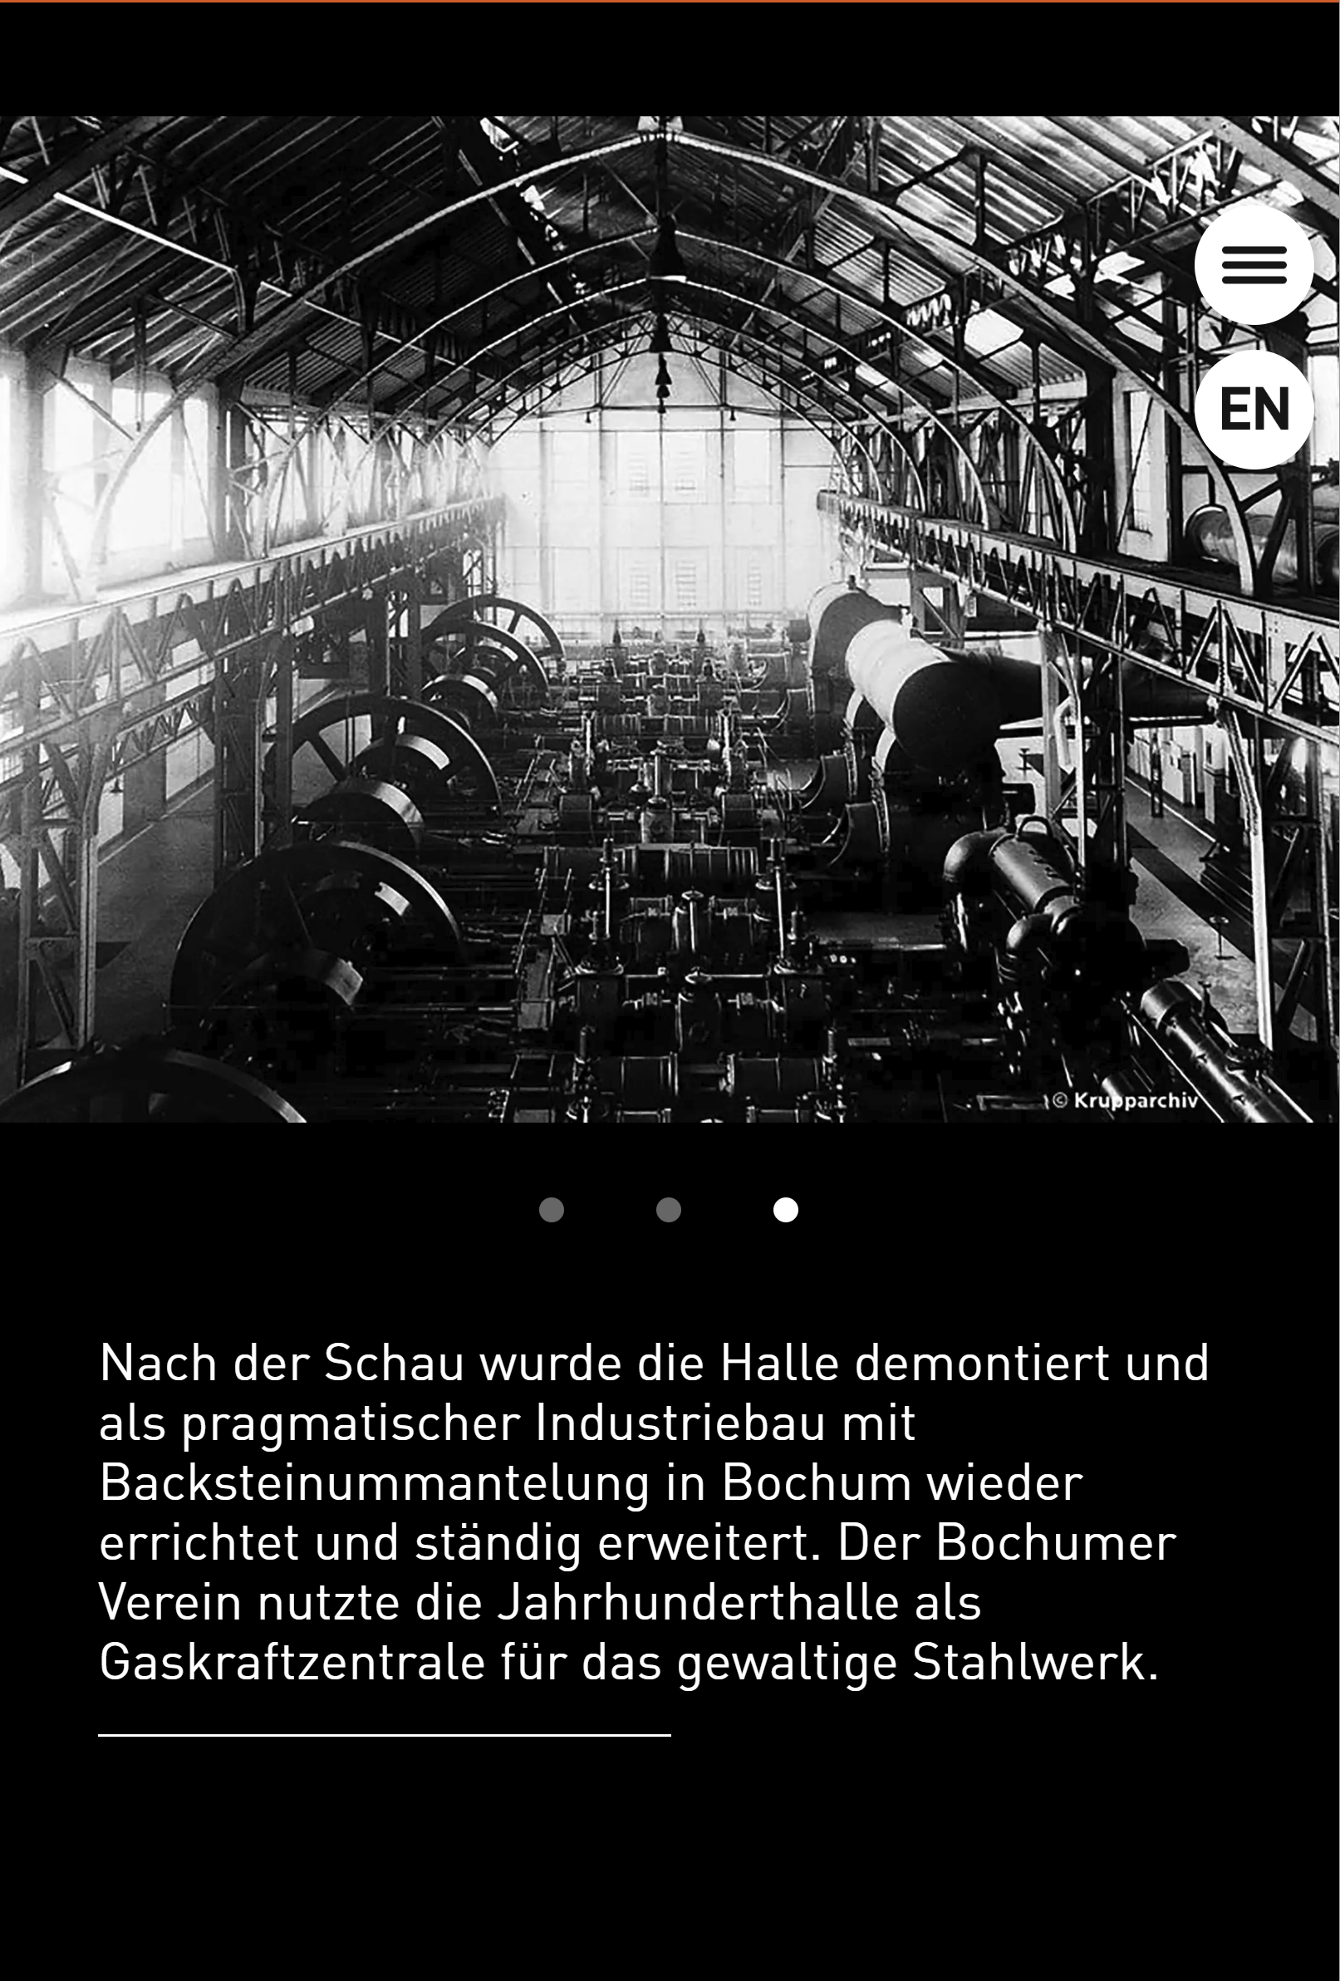
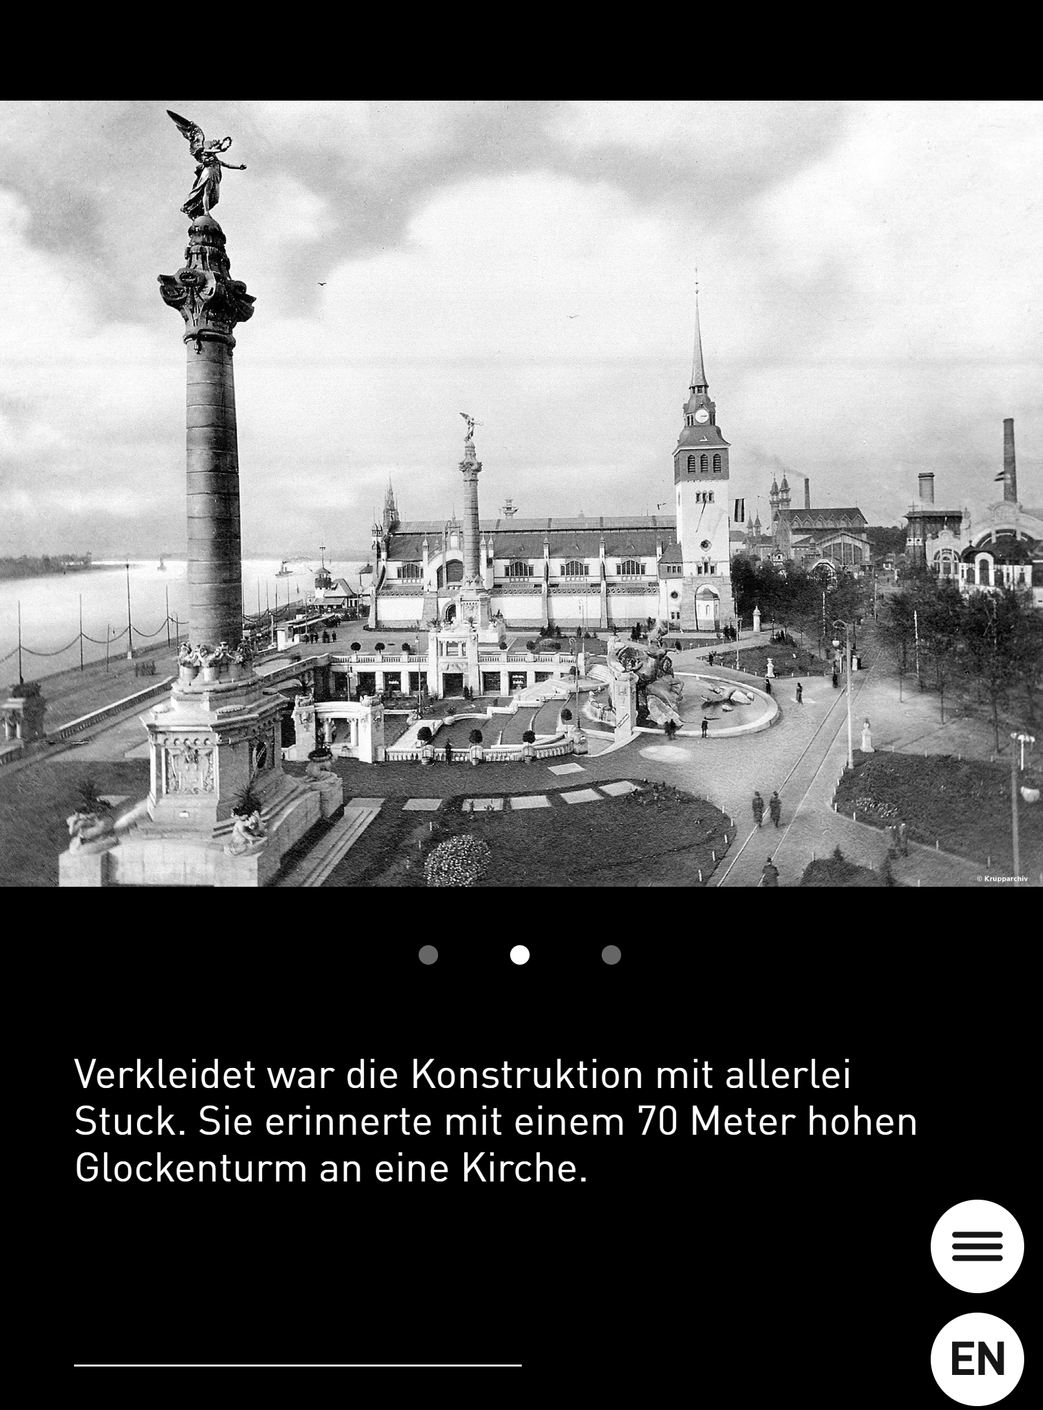
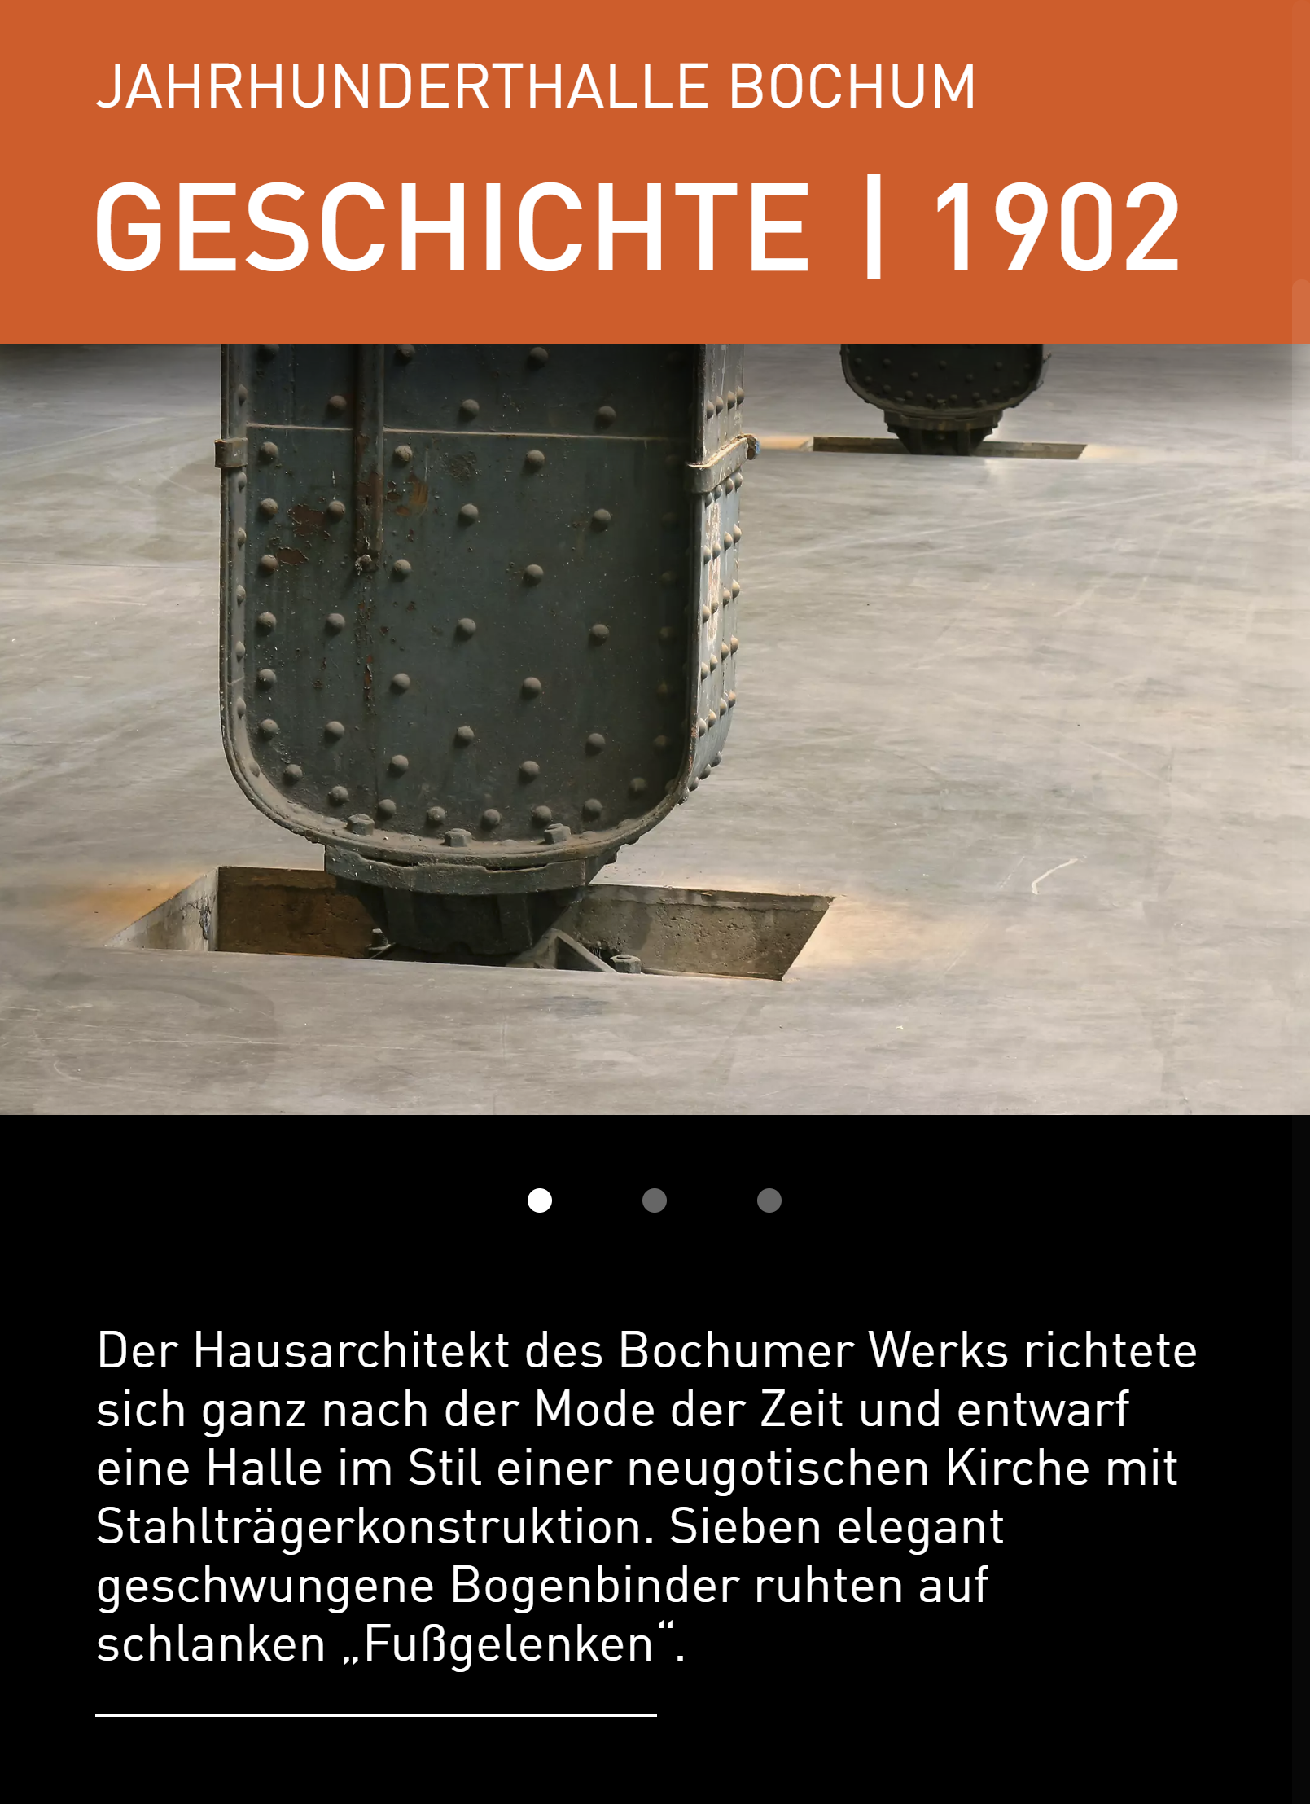
Module m07

The m07 module template consists of multiple pieces of content, each with its own image and description

{
"type": "m07",
"year": "1902",
"media": [
{
"type": "image",
"src": "01_Geschichte/T07_01_Geschichte_02_01.webp",
"description": {
"copy": "Der Hausarchitekt des Bochumer Werks richtete sich ganz nach der Mode der Zeit und entwarf eine Halle im Stil einer neugotischen Kirche mit Stahlträgerkonstruktion. Sieben elegant geschwungene Bogenbinder ruhten auf schlanken „Fußgelenken“. "
}
},
{
"type": "image",
"src": "01_Geschichte/T07_01_Geschichte_02_02.webp",
"description": {
"copy": "Verkleidet war die Konstruktion mit allerlei Stuck. Sie erinnerte mit einem 70 Meter hohen Glockenturm an eine Kirche. "
}
},
{
"type": "image",
"src": "01_Geschichte/T07_01_Geschichte_02_03.webp",
"description": {
"copy": "Nach der Schau wurde die Halle demontiert und als pragmatischer Industriebau mit Backsteinummantelung in Bochum wieder errichtet und ständig erweitert. Der Bochumer Verein nutzte die Jahrhunderthalle als Gaskraftzentrale für das gewaltige Stahlwerk."
}
}
]
},

Today

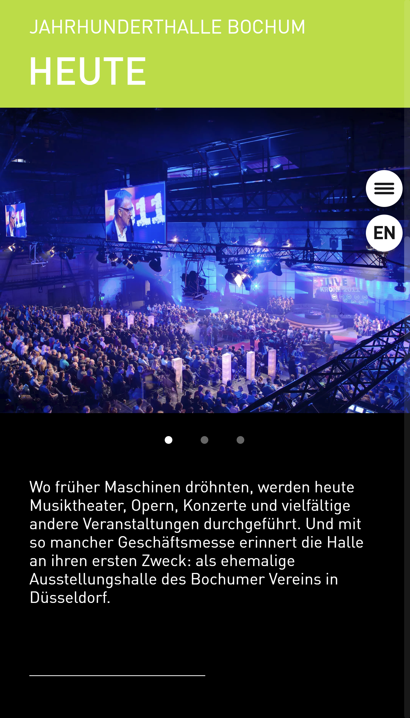
"id": "today",
"class": "category-today",
"headline": "Jahrhunderthalle Bochum",
"subline": "HEUTE",

Service
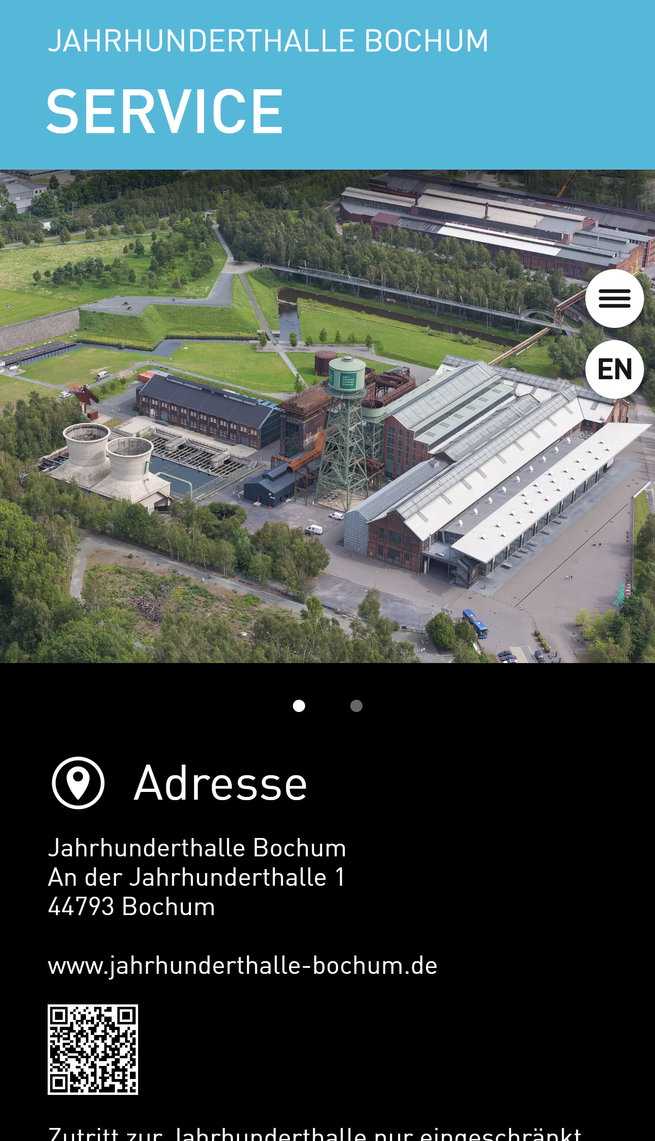
"id": "service",
"class": "category-service",
"headline": "Jahrhunderthalle Bochum",
"subline": "SERVICE",
"modules": [

Module m09
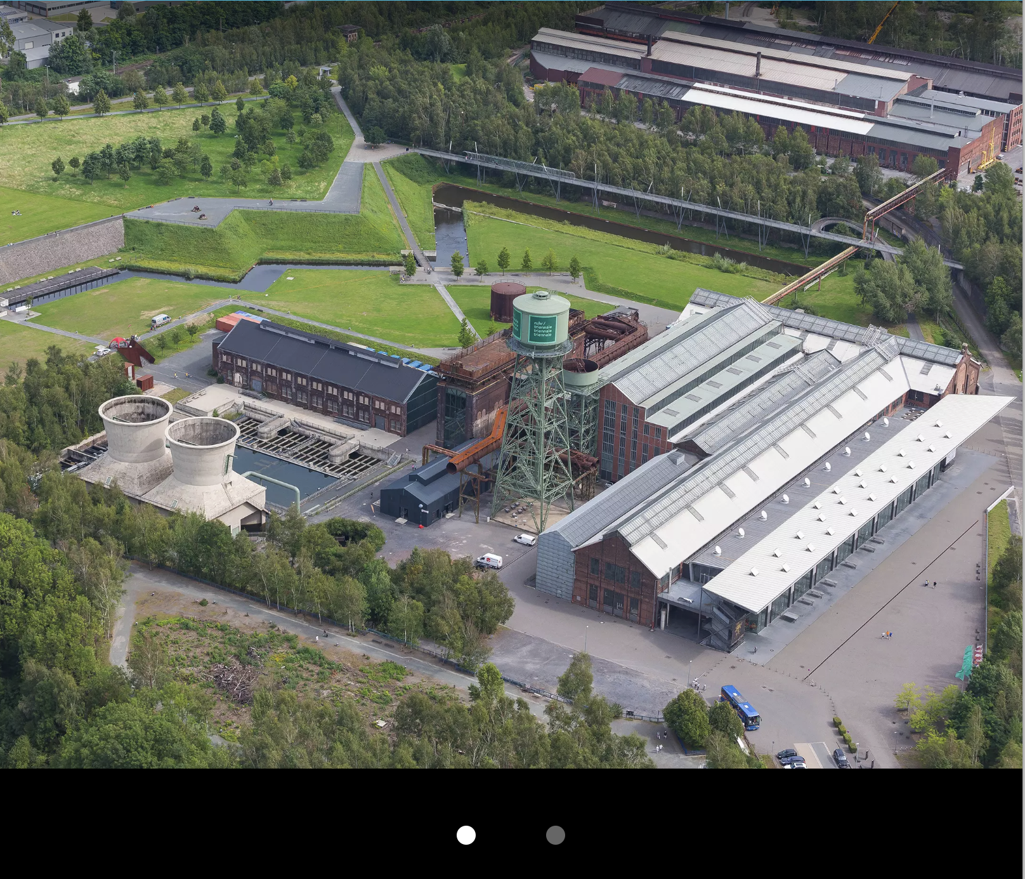
"type": "m09",
"media": [
{
"type": "image",
"src": "03_Service/T07_03_Service_01_01.webp"
},
{
"type": "image",
"src": "03_Service/T07_03_Service_01_02.webp"
}
],

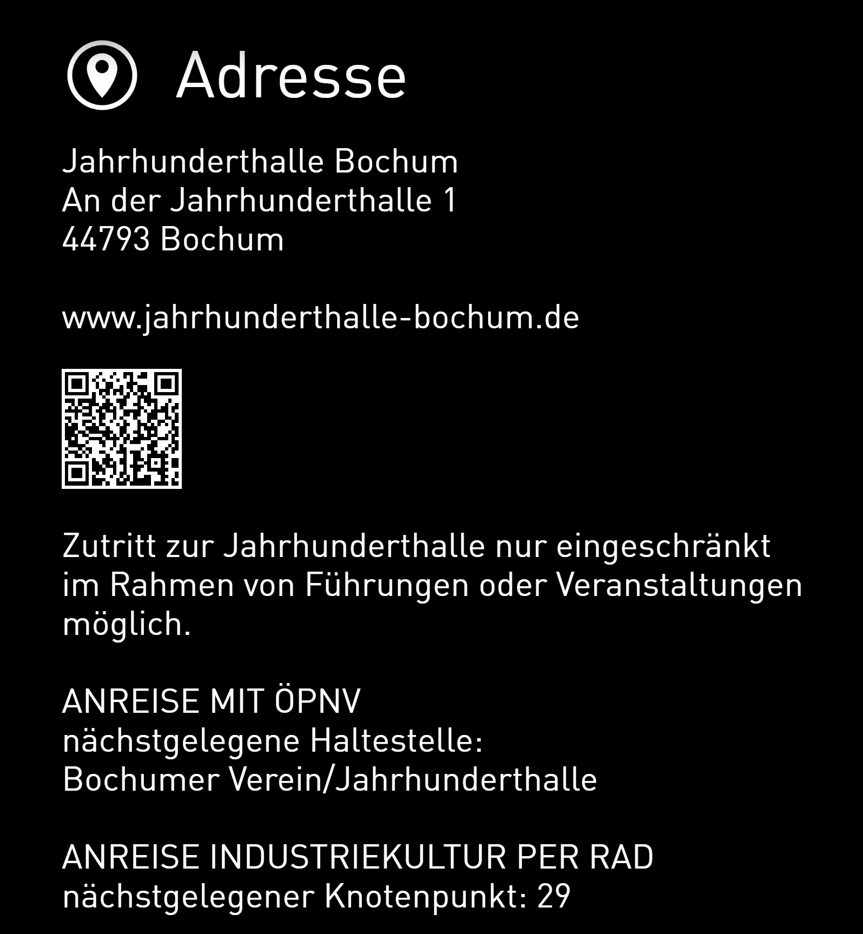
"address": {
"title": "Adresse",
"detail": "Jahrhunderthalle Bochum<br/>An der Jahrhunderthalle 1<br/>44793 Bochum",
"link": "www.jahrhunderthalle-bochum.de",
"route": "Zutritt zur Jahrhunderthalle nur eingeschränkt im Rahmen von Führungen oder Veranstaltungen möglich.<br/><br/>ANREISE MIT ÖPNV<br/>nächstgelegene Haltestelle: <br/>Bochumer Verein/Jahrhunderthalle<br/><br/>ANREISE INDUSTRIEKULTUR PER RAD<br/>nächstgelegener Knotenpunkt: 29",
"qrcode": "https://www.jahrhunderthalle-bochum.de/service/anfahrtpark",

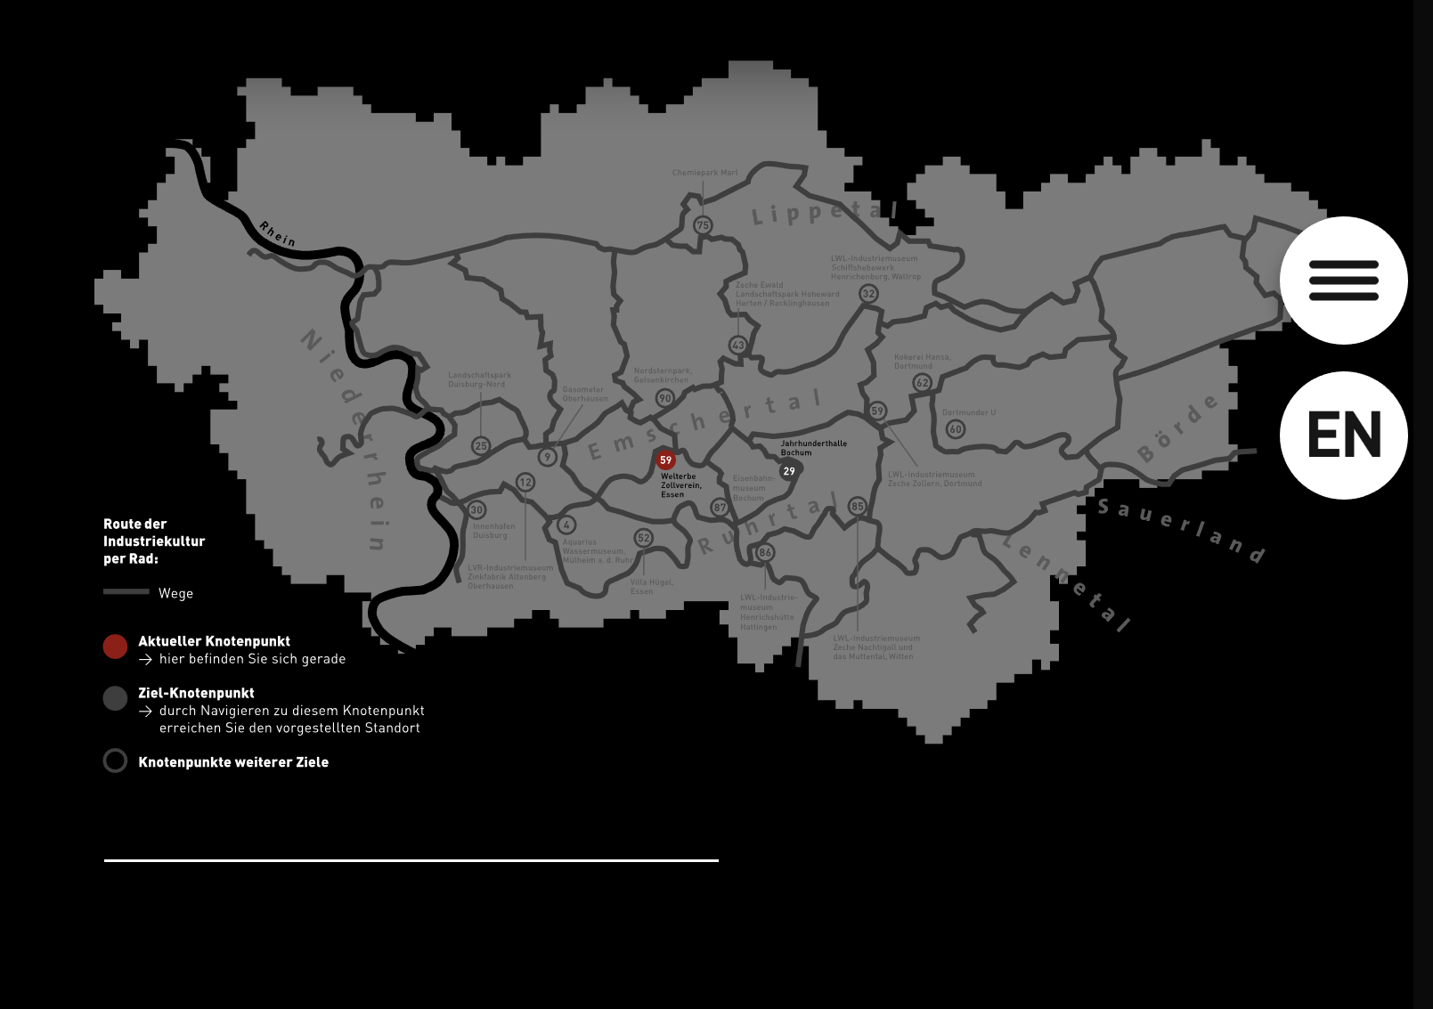
"svg": "03_Service/T07_03_Service_Fahrrradkarte_DE.svg"
},

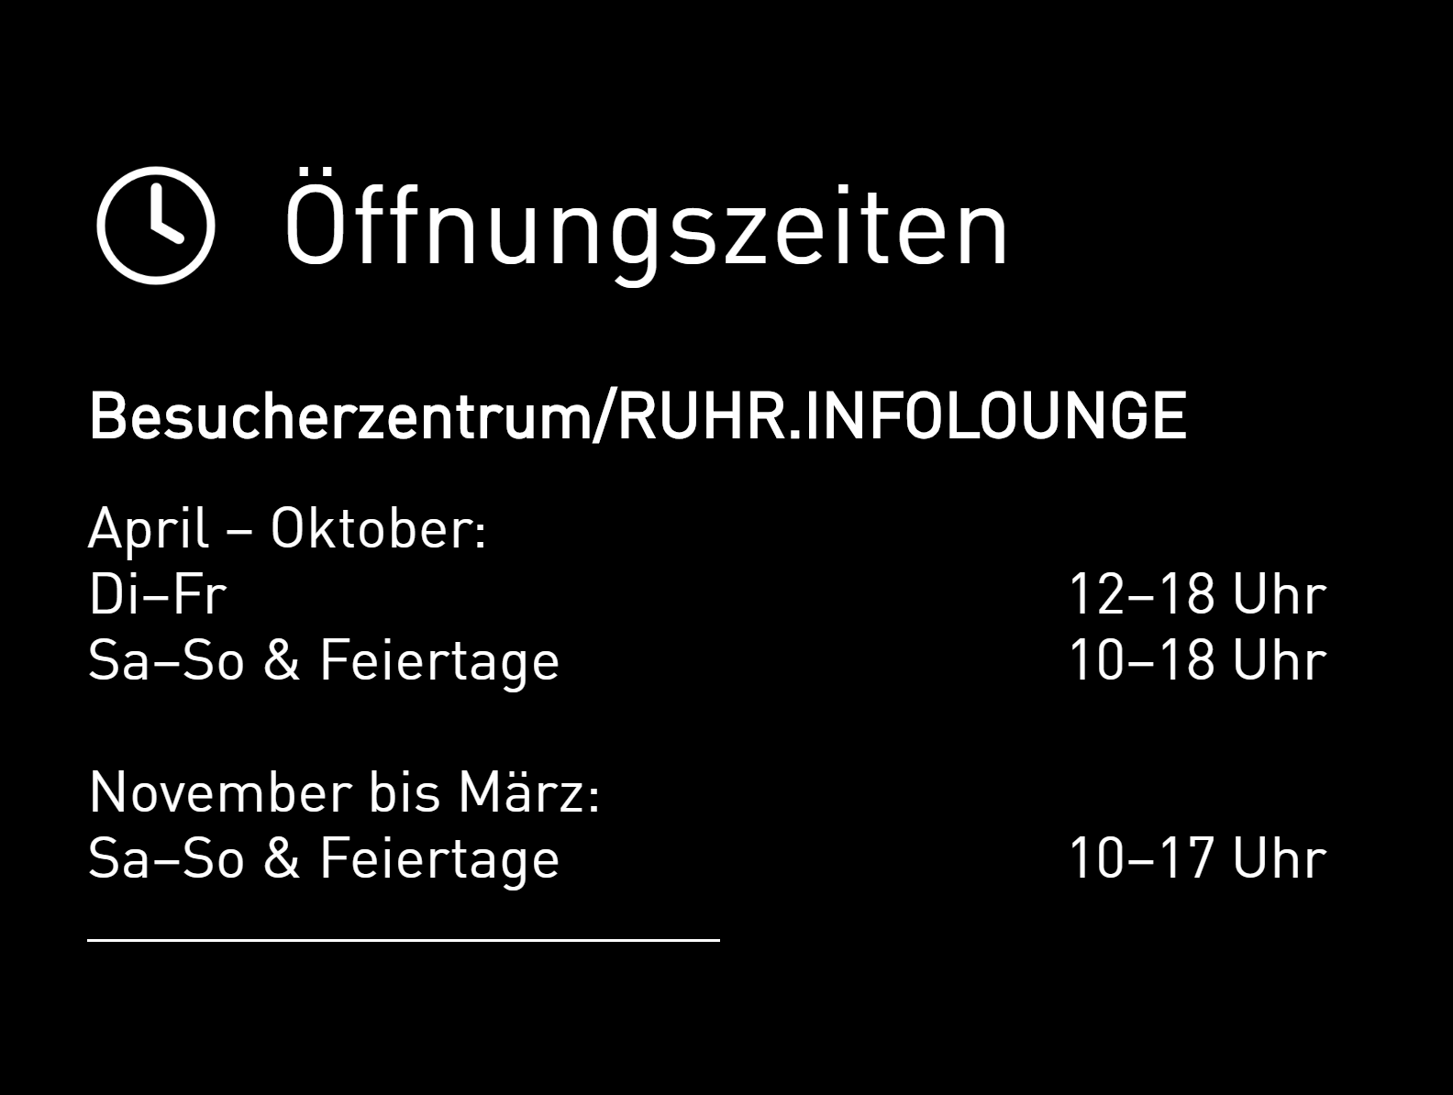
"opening": {
"title": "Öffnungszeiten",
"pre": {
"title": "Besucherzentrum/RUHR.INFOLOUNGE"
},
"visitor": {
"days": [
{
"label": "April – Oktober:",
"time": ""
},
{
"label": "Di–Fr",
"time": "12–18 Uhr"
},
{
"label": "Sa–So & Feiertage",
"time": "10–18 Uhr"
}, {
"label": "&nbsp;",
"time": "&nbsp;"
},
{
"label": "November bis März:",
"time": ""
},
{
"label": "Sa–So & Feiertage",
"time": "10–17 Uhr"
}
]
}
},

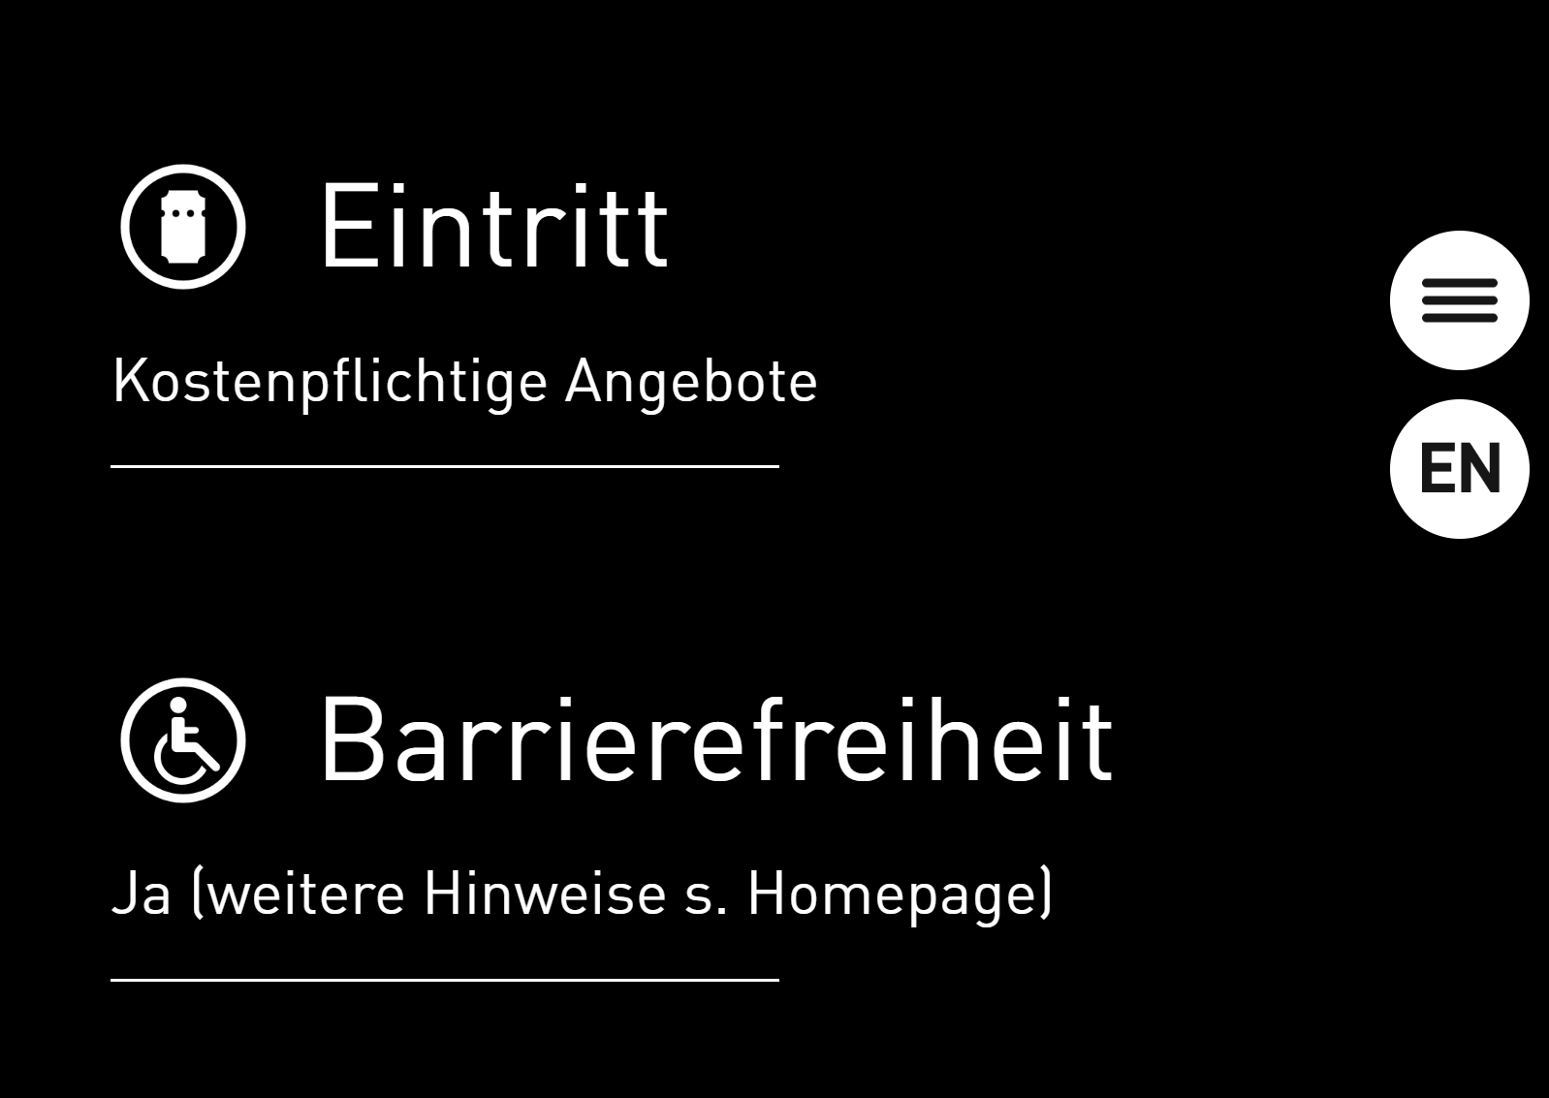
"modules": [
{
"icon": "ticket",
"title": "Eintritt",
"description": "Kostenpflichtige Angebote "
},
{
"icon": "handicapped",
"title": "Barrierefreiheit",
"description": "Ja (weitere Hinweise s. Homepage) "
},

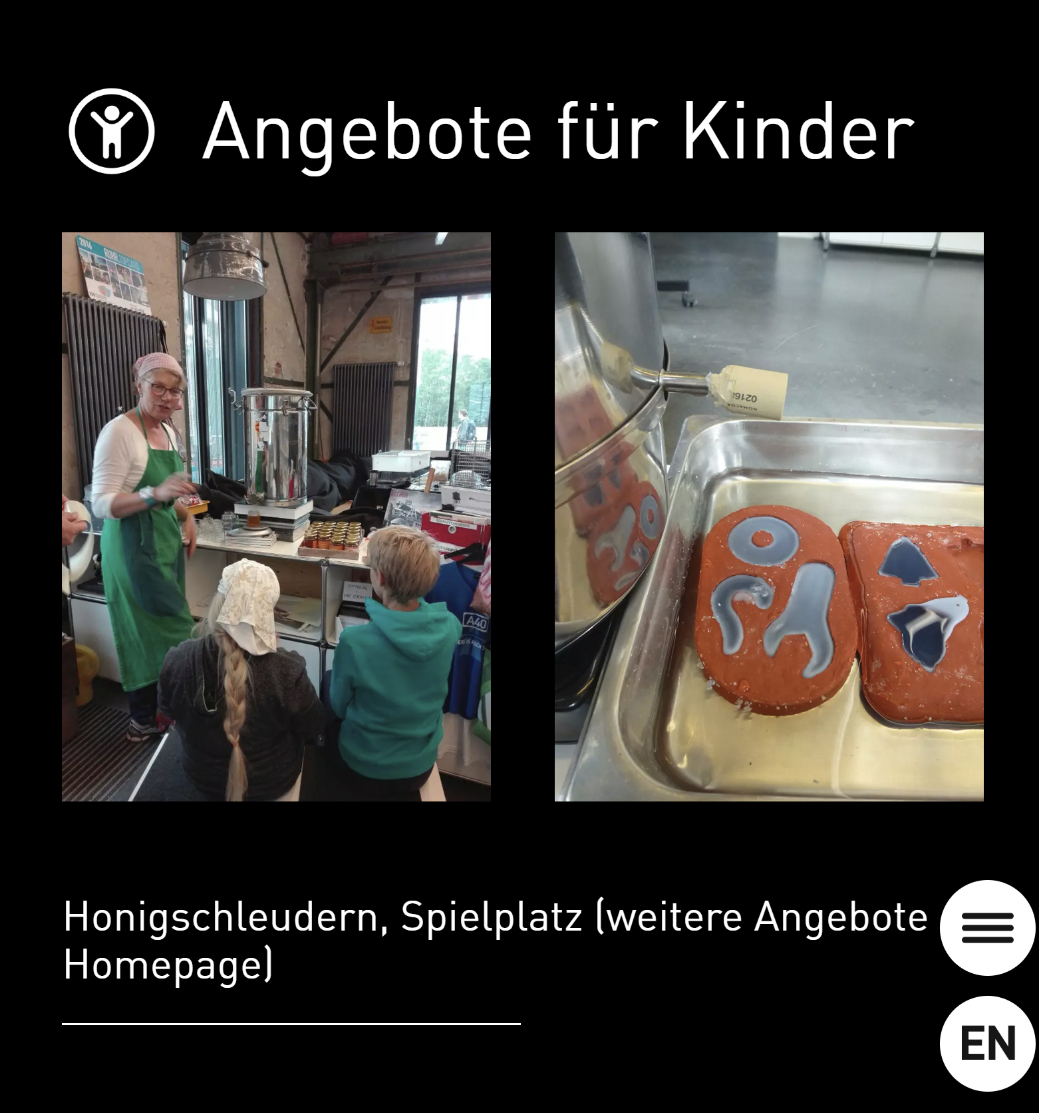
{
"icon": "kids",
"title": "Angebote für Kinder",
"images": [
"03_Service/T07_03_Service_05_01.webp",
"03_Service/T07_03_Service_05_02.webp"
],

"description": "Honigschleudern, Spielplatz (weitere Angebote s. Homepage) "
},

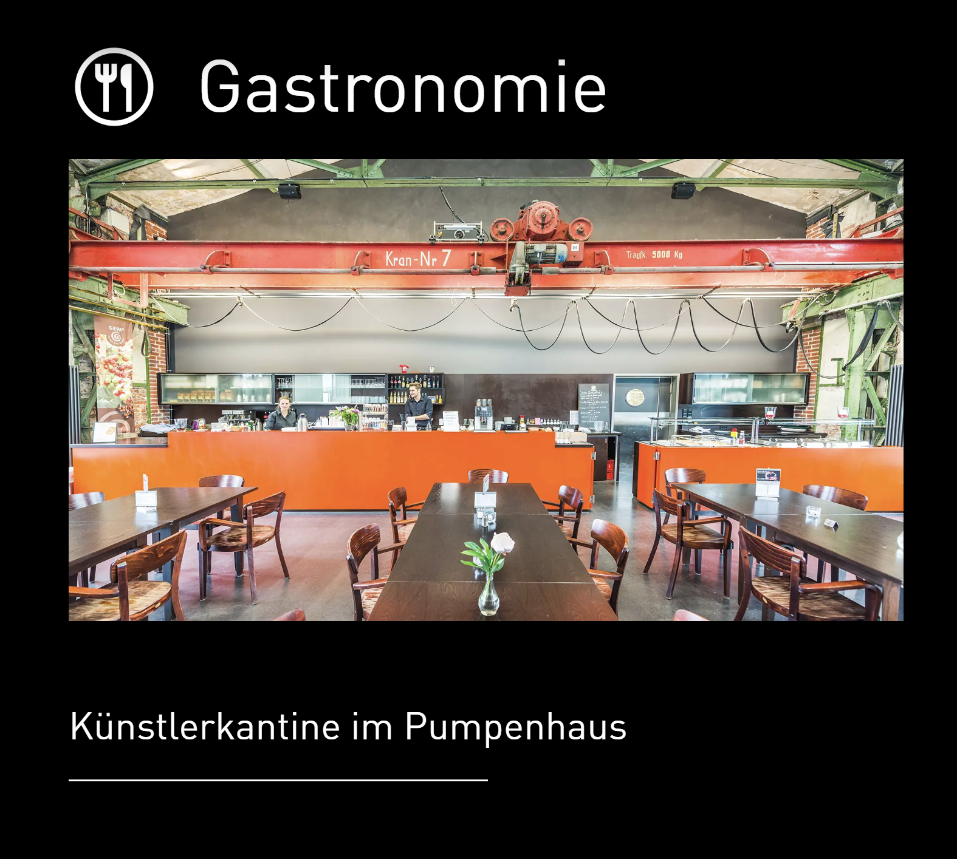
{
"icon": "gastro",
"title": "Gastronomie",
"image": "03_Service/T07_03_Service_06.webp",
"description": "Künstlerkantine im Pumpenhaus "
},

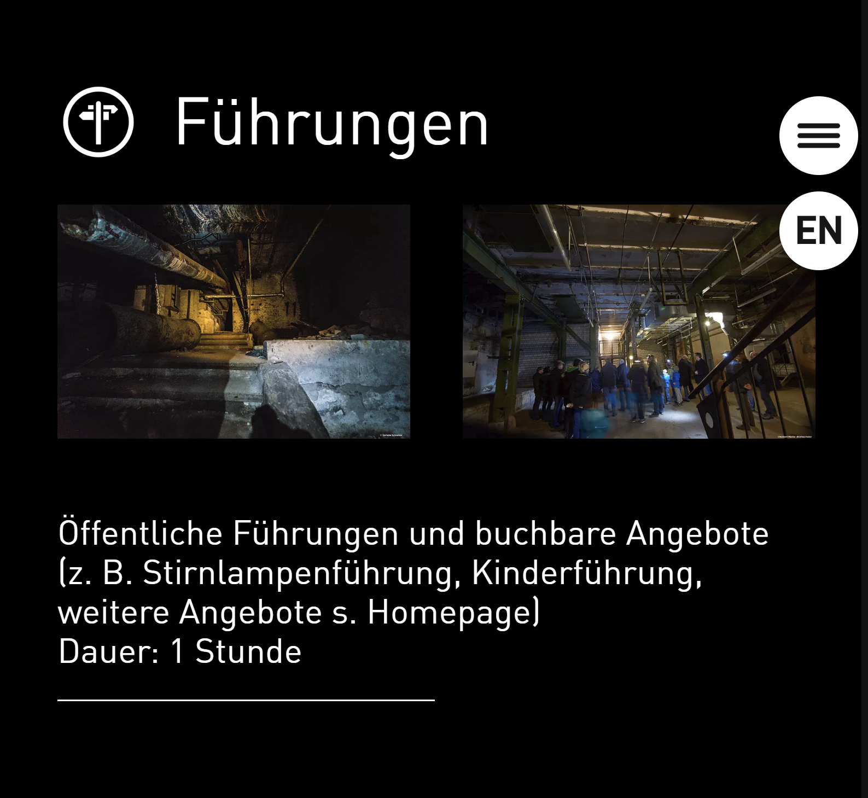
{
"icon": "tour",
"title": "Führungen",
"images": [
"03_Service/T07_03_Service_07_01.webp",
"03_Service/T07_03_Service_07_02.webp"
],
"description": "Öffentliche Führungen und buchbare Angebote (z. B. Stirnlampenführung, Kinderführung, weitere Angebote s. Homepage) <br/>Dauer: 1 Stunde"
},



{
"icon": "weitere_Attraktionen",
"title": "Weitere Attraktionen",
"description": "Festspielhaus der Ruhrtriennale "
}
]
},

Module m10
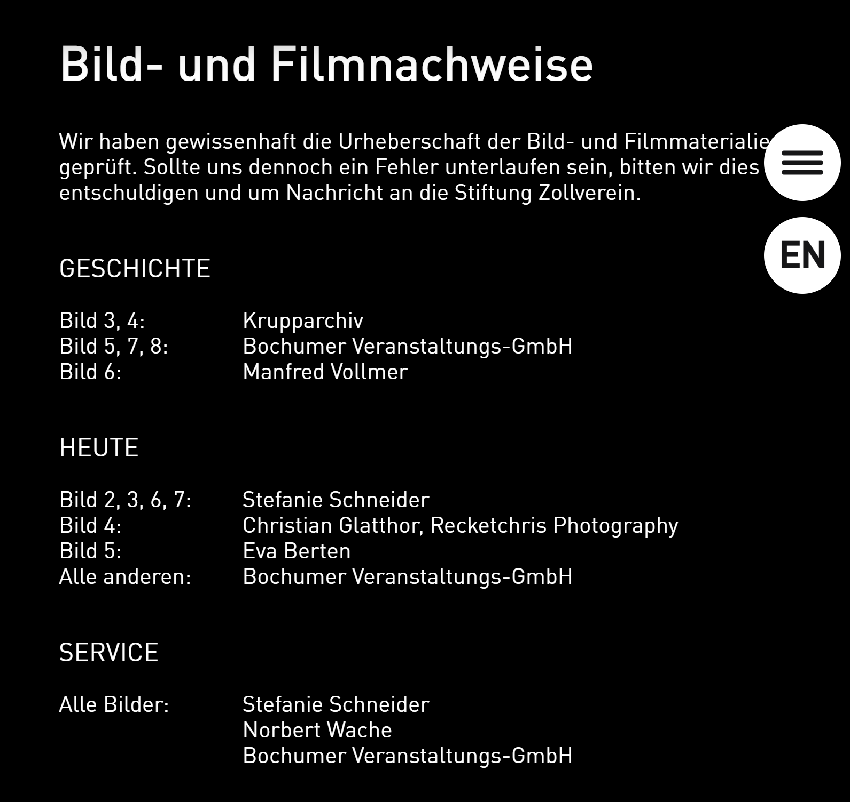
{
"type": "m10",
"headline": "Bild- und Filmnachweise",
"description": "Wir haben gewissenhaft die Urheberschaft der Bild- und Filmmaterialien geprüft. Sollte uns dennoch ein Fehler unterlaufen sein, bitten wir dies zu entschuldigen und um Nachricht an die Stiftung Zollverein.",

"sections": [
{
"title": "Geschichte",
"entries": [
{
"label": "Bild 3, 4:",
"description": "Krupparchiv"
},
{
"label": "Bild 5, 7, 8:",
"description": "Bochumer Veranstaltungs-GmbH"
},
{
"label": "Bild 6: ",
"description": "Manfred Vollmer"
}
]
},
{
"title": "Heute",
"entries": [
{
"label": "Bild 2, 3, 6, 7:",
"description": "Stefanie Schneider"
},
{
"label": "Bild 4:",
"description": "Christian Glatthor, Recketchris Photography"
},
{
"label": "Bild 5:",
"description": "Eva Berten"
},
{
"label": "Alle anderen:",
"description": "Bochumer Veranstaltungs-GmbH"
}
]
},
{
"title": "Service",
"entries": [
{
"label": "Alle Bilder:",
"description": "Stefanie Schneider"
},
{
"label": "",
"description": "Norbert Wache"
},
{
"label": "",
"description": "Bochumer Veranstaltungs-GmbH"
}
]
}
]
}

HTML
Make a copy of the T99.html file and add it to the HTML folder.
Rename the file to the correct module number cTXX.html

IMAGES
Images should be added to the images folder. Each module should have its own folder within the images folder. The folder is called TXX, where XX is the module number.

Inside the module folder, organize the images by section. Each section has a folder.
The naming convention is as follows:

TXX_[FolderName]_BB_ZZ.webp

TXX: Module Number
[FolderName]: Name of the section/folder name
BB Order of appearance. If it is a section with multiple sliding images, give all images in that section the same number
_ZZ Optional only if images are part of a multiple image sliding group. If it is to be shown as a single image, omit this part.
.webp save all images as .webp

Example:
T05_01_Geschichte_01_01.webp

Example of folder structure and naming convention:
  - images
    - TXX
      - 00_Idle_Start
        - TXX_00_Start_01.webp
      - 01_Geschichte
        - TXX_01_Geschichte_01.webp
        - TXX_01_Geschichte_02_01.webp
        - TXX_01_Geschichte_02_02.webp
        - TXX_01_Geschichte_02_03.webp
        - TXX_01_Geschichte_03.webp
      - 02_Heute
        - TXX_02_Heute_01.webp
        - TXX_02_ Heute _02_01.webp
        - TXX_02_ Heute _02_02.webp
        - TXX_02_ Heute _02_03.webp
        - TXX_02_ Heute _03.webp
      - 03_Service
        - TXX_03_Service_01_01.webp

VIDEOS
Create a new folder inside the videos folder for each module. Call the folder TXX, where XX is the module number. Add videos to the TXX folder with the naming convention:

TXX_[SectionName]_BB.mp4

TXX: Module Number
[SectionName]: Section Number and Section Name “XX_Section”
BB Order of appearance.
.mp4 save all videos as .mp4

Example:
T05_00_Idle_01.mp4

Video File Structure Example:
  - Videos
    - TXX
      - TXX_00_Idle_01.mp4

BAT FILE
Create a new bat file by duplicating the T99.bat template file.
Rename it to TXX.bat where XX is the new module number.

